Atomic Structure Assignment – Validation Test
Name:
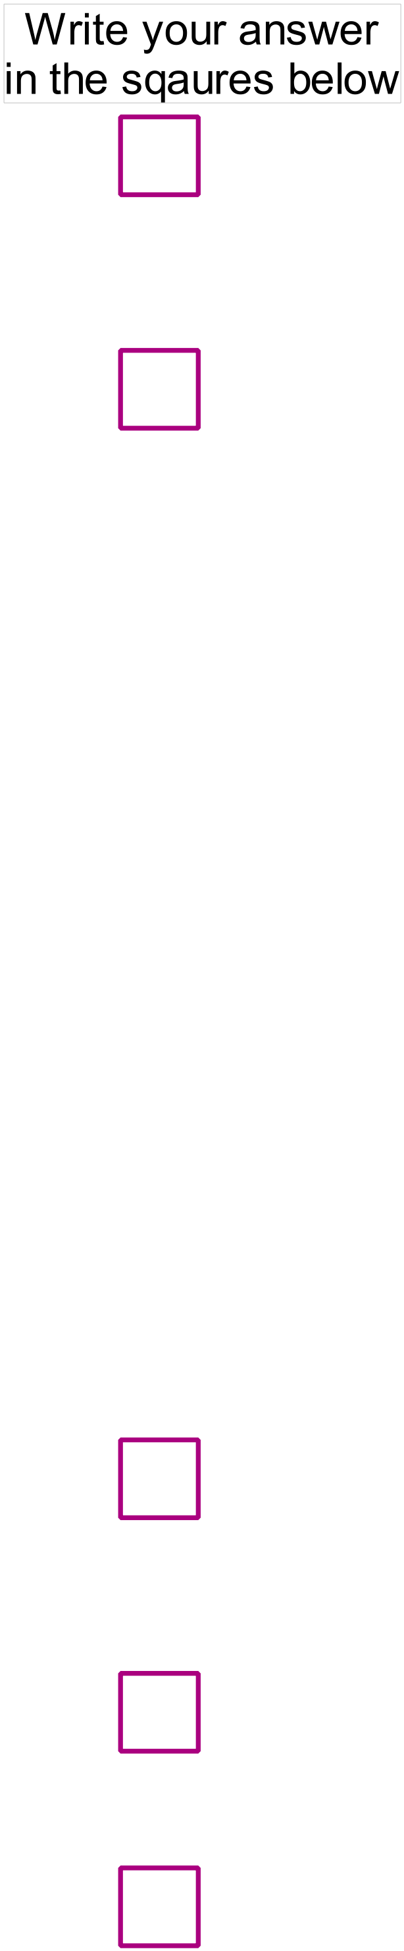 /35
- Which of the following represents a chromium (III) ion with 28 neutrons?
  - 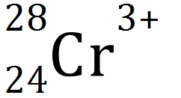
  - 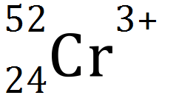
  - 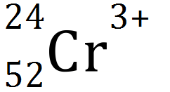
  - 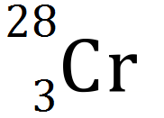

- Which one of the following species does not have an electron configuration of 2,8?
  - Ne
  - F⁻
  - Na
  - O²⁻

- The successive ionisation energies for an element, Y, are shown below.

Equation for process | Ionisation Energy  (kJ mol⁻¹)
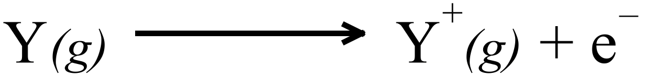 | 1000
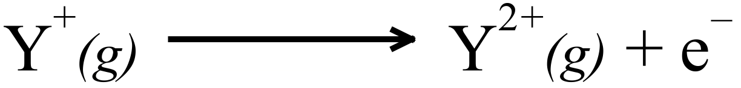 | 2252
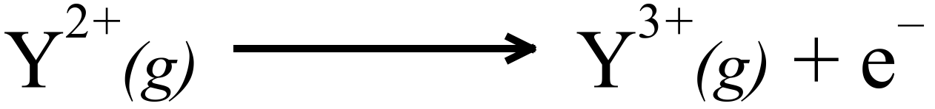 | 3357
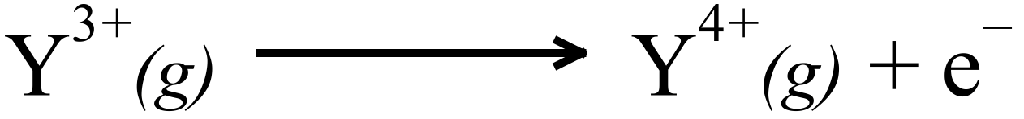 | 4556
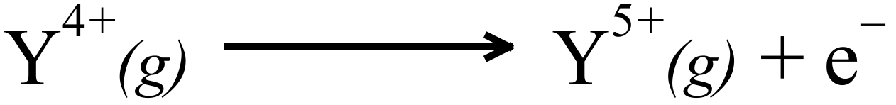 | 7004
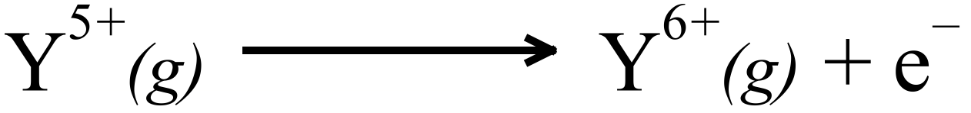 | 8496
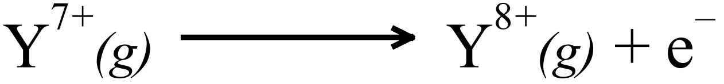 | 27107
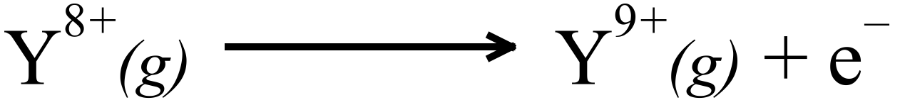 | 31719
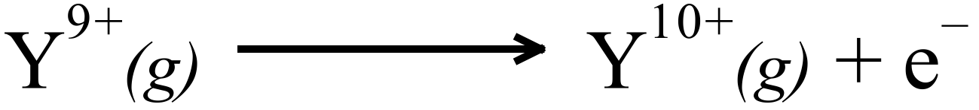 | 36621
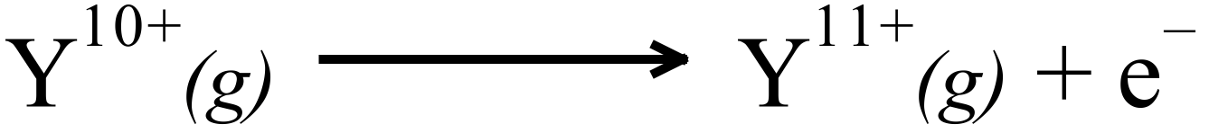 | 43177
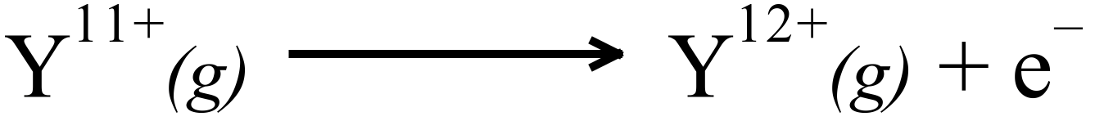 | 48710
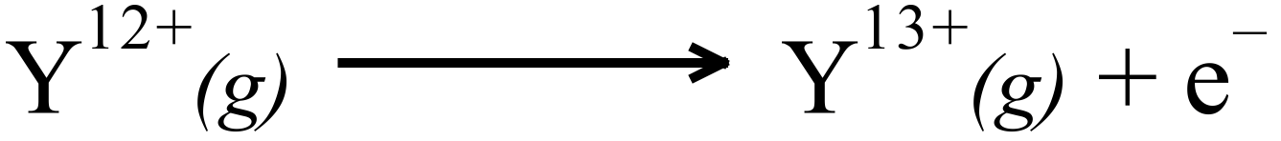 | 54460

The element is most likely to be Y is…
  - Oxygen
  - Sulphur
  - Chlorine
  - Phosphorus

- Which of the following has the greatest core charge?
  - An aluminium atom
  - A chlorine atom
  - A magnesium ion
  - An oxide ion

- Which of the following statement about Group 1 metals is untrue?
  - 1 electron is present in the valence shell of the metal.
  - Their chemical reactivity decreases with atomic number.
  - Their +1 (positive) ions have noble gas configuration.
  - Their core charge is constant.
- Complete the following statements:
  - Ionisation energy increases across the periodic table because… (2)

  - Ionisation energy decreases down groups in the periodic table because… (2)

- For each of the following pairs of atoms explain which has the larger atomic radii:

  - A Nitrogen atom or an Oxygen atom (2)

  - A Chlorine atom or a Bromine atom (2)

  - A Magnesium atom or a Magnesium ion (2)

- List four different species that have the electron configuration of 2,8. (2)

- Five elements and their electronic configurations are as follows:
Na: 2,1 Mg: 2,2 He: 2 O:2,6 S:2,8,6
- In a chemical reaction which element is most likely to: (3)
    - Gain 2 e⁻?
    - Lose 2 e⁻?
    - Not react?
- Which element(s) form: (3)
    - Covalent bonds?
    - Metallic bonds?
    - Forms a diatomic element?
- Which element: (2)
          - Is the most reactive?
          - Has the smallest radius?

- A plot showing the successive ionisation energies of Magnesium is given below.

- Define ionisation energy. (1)

- Explain the gentle increase between the first and second ionisation energies for magnesium (1)

- Explain the significant increase in moving from the second to the third ionisation energy for magnesium. (1)

- Explain the gentle increase between the third and tenth ionisation energies for magnesium (1)

- On the chart above indicate where you would expect the eleventh and twelfth ionisation energies for magnesium to be. (1)

- Explain your reason for this location. (1)

- On the same axes above, sketch (and label) the graph you would anticipate for the first eight successive ionisation energies of calcium. (1)

- On the same axes above, sketch (and label) the graph you would anticipate for the first eight successive ionisation energies of sodium. (1)

- Explain the position of the graphs for magnesium and sodium. (2)

